SWH + 2nd Zone Hydronic

Quick Reference Manual

Sensor Diagram
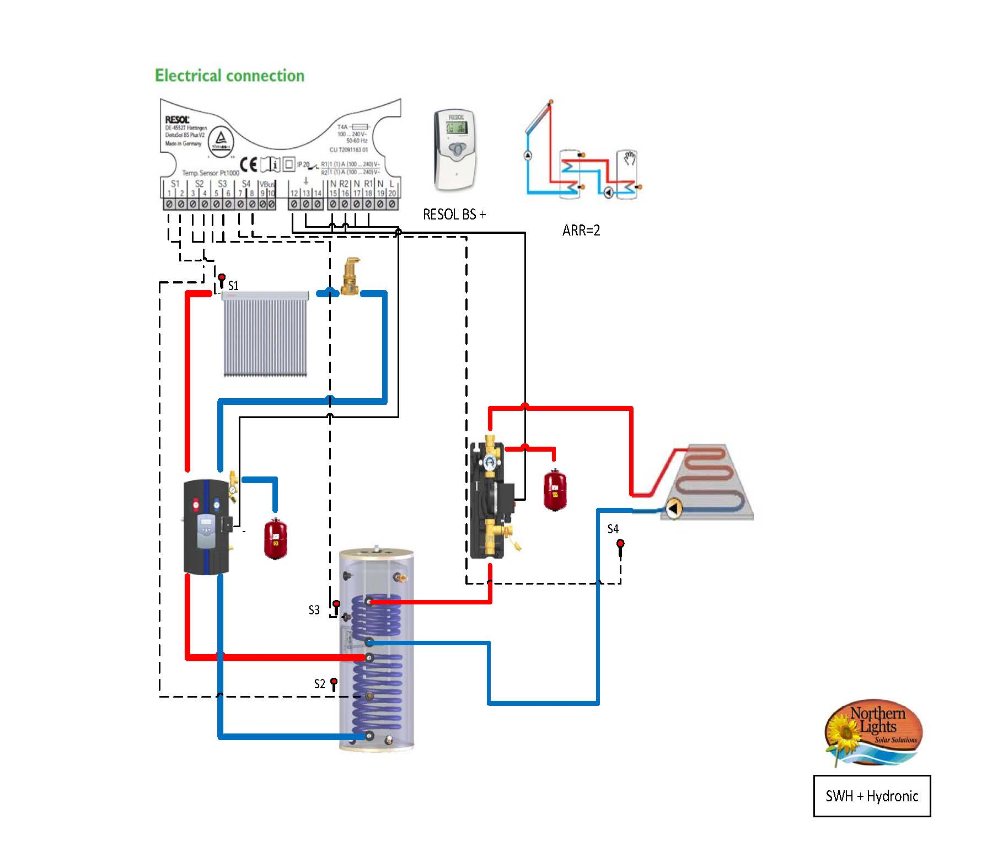

Electrical Diagram 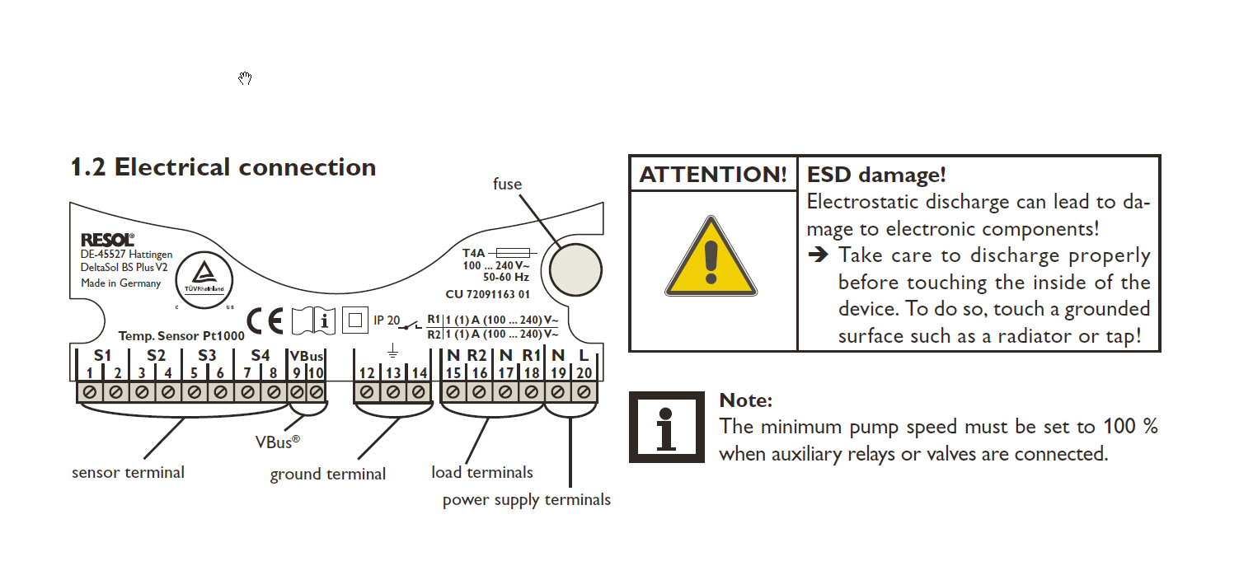

General

Note Prior to Installation read the RESOL BS PLUS Installation Manual as this reference guide is only a general overview!
This Pre-Engineered Package describes how to add a Hydronic in-floor heating loop to a hot water solar system equipped with a dual coil storage tank. When using a storage tank one can size the solar array so that during the day time it covers the demand for hot water usage plus the day time needs of the Hydronic system and it further store excess heat, to be used during the evening. The Hydronic system becomes a heat dump, to funnel excess heat produced by the solar array, and not needed for domestic hot water, to the floor. The energy is transferred into the tank from the solar system and from the backup electric element. The DeltaSol BS1/plus controller allow some of the energy to be transferred to the Hydronic system but stops this transfer if the temperature at the top of the tank falls below the set value of MN3O. This minimum temperature is determined by the domestic hot water temperature requirements. Temperature sensor S3 and S4 and ARR=2 are used, which provide a second differential control function to control output R2 and the Hydronic pump loop. The diagram, that displays on the controller with ARR=2 selected, shows a 2nd tank. The Hydronic system can be viewed as substituting for this 2nd tank. T he backup electric heating element is controlled through its independent temperature switch, TS, that comes with the tank.
Since this system, supplies heat to the radiant in-floor system, in the winter, there is no equivalent heat dump for summer operation. Thus during the summer months when the Hydronic heat system is not operating, the heat output from the collectors must be reduced so that they only produce enough heat for the domestic water requirements. The easiest way this can be achieved is with covers, or by diverting to a summer load such as a pool. The system will need to be set to ARR=1 in the summer so that the 2nd loop is deactivated if an alternate heat dump is not available.
The heat transfer control relies on the solar circuit and the Hydronic s circuit both being properly charged with glycol, the glycol % being selected for the freezing climate that it will be used in, that the air in the circuits has been properly removed and the systems having been pressurized while cold and each has been properly leak tested. Note that the expansion tank’s pressure must match the systems cold static pressure (Ps).
The tank comes with an electric 4.5 Kw Heater Element that can be optional energized to guarantee a minimum temperature supply level in the tank. The thermostat for the electric element is adjustable from 110 -160°F. We suggest initially it be kept at the factory default of 120°F. Consult with an electrician to ensure the element is installed properly according to local electrical codes.

RESOL BS Plus – Suggested Settings
ARR | 2 | System Arrangement 2
DTO | 12 F (Ra) | Delta ON S1-S2
DTF | 8 F(Ra) | Delta Off S1-S2
SMX | 185 F (Ra) | Maximum Tank Temp
EM | 260 F | Emergency Shut Down
DT30 | 12 F (Ra) | Delta ON S3-S4
DT3F | 8 F (Ra) | Delta OFF S3-S4
SMX | 185 F | Maximum Tank Temp (S2)
EM | 260 F | Emergency Shut Down (S1)
n1MN | 100% | Solar Pump at 100%
MN30⁺ | 120 | Minimum tank temp off (S3)
MN3F⁺ | 125 | Minimum tank temp on (S3)
MX30* | 80 | Maximum tank temp off (S4)
MX3F* | 78 | Maximum tank temp on (S4)
N2MN | 100% | P2- Secondary Pump at 100%
Options
OCC | ON | Optional Collector Cooling
CMX | 230 F | Max collector temp
OSTC | ON | Optional Tank Cooling
OHOL | ON | Optional Holiday Cooling
THOL | 100 F | Holiday Tank Cooling temperature
+ Setting will determine the minimum hot water supply – adjust accordingly
* Setting will control the room temperature similar to a thermostat – adjust accordingly

System Settings

First let’s describe the control of the solar circuit. Pump P1 is controlled through the DTO and DTF differential temperature settings, which use the S1 and S2 sensors. S1 monitors the collector(s) outlet temperature and S2 monitors the temperature of the water in the bottom of the tank. The ON differential temperature, DTO, is kept at the default settings of DTO=12F (Ra) and DTF=8F (Ra). The parameter SMX, which in this case represents the maximum desired temperature of the water in the bottom of tank, is as also monitored by S2. We have set it to SMX=185F. Thus, in summary, pump P1 will be turned on once ∆T (S1-S2) reaches 12°F and stays on until either the ∆T (S1-S2) falls below 8°F or the temperature of the water at the bottom of the tank reaches the setting of SMX=185°F. In that case P1 stops and the collector fluid will rise in temperature. If the system max temp EM (measure by S1) is exceed the system will also shut down to avoid hot fluid or steam to be circulated through the system avoiding damages. Note SMX should be set lower if the Hydronic loop has a maximum operating temperature so that it will not exceed this temperature. Example if the floor loop should not exceed 160 F then set SMX=160. Alternatively a mixing valve should be used.

Heat exchange from the tank to the Hydronic s loop involves the temperature sensors S3 and S4 and a second differential temperature control function DT3, which controls the output R2 and subsequently the Hydronic s pump, P2. It is implemented when ARR=2 is selected. S3 is installed in the top of the tank and S4 measures the temperature of the floor or the air room air temperature. The ON differential temperature, S3-S4 (DT3O), is set to default DT3O=12F (Ra) and the OFF differential temperature is set to DT3F=8F (Ra). However should the tank temperature fall below a minimum setting MN3O, which we set to MN3O=120F heat transfer will be stopped and it will remain stopped until the S3 temperature has risen to MN3F = 125F. These values are selected to maintain a useful temperature for domestic hot water in the tank and can be adjusted accordingly. Heat transfer is also stopped should the floor temperature or room temperature as measured by S4 exceed a set high limit set value such as MX3O=80F (similar to a heating thermostat off setting). Heat transfer stays stopped until the temperature has fallen to the set MX3F value. If you wish to use this limit function as a thermostat, then you would set MX3F close to MX3O, for example MX3F=78F. Minimum pump speed for P2 is set to 100%, i.e., n2MN=100%
It is important that temperature sensors, S1 to S4, measure the temperature correctly. S1 should be in the thermal well at the outlet end of the last collector. S2 should be in the bottom thermowell of the solar tank. S3 is inserted in the tank’s top thermowell. S4 will measure the desired 2nd zone temperature and should be placed in/on the floor at a location that is representative of the average floor temperature or alternately placed in the room to measure the average room temperature.
Flow Rate and Pump Speed - Since R1 output controls the solar pump its variable speed capability must be turned off. Therefore the minimum speed parameter, n1MN, must be set at 100%. The collector flow rate is determined by the manufactures suggestion and collector configuration chosen. If there are only a few collectors, they can be connected in series. Use the pump speed selection (1,2,3) to obtained the desired manufactures recommended flow rate between .75 gpm-1.5 gpm. If with the normal flow rate the outlet temperature of the last collector gets too high (S1), then simply increase the flow rate to drop the collector ∆T. A cooler operating solar system is more efficient! If there are a large number of collectors, they are then best arranged in a series/parallel arrangement to keep the total collector arrangement ∆T to an acceptable value. In that case the P1 flow needs to be a multiple of the number of parallel circuits used. For example if we use a collector design flow rate of 1 gpm and there are 3 parallel rows, then the system flow rate should be at least 3 x 1 gpm =3 gpm.
Optional Collector Cooling – OCC It is recommended to implement the Collector cooling function by setting OCC=ON and setting the maximum collector temperature setting, CMX, to a value that is safely below the boiling point of the glycol/water mixture chosen. Assuming a 50/50 propylene glycol mixture, a setting of CMX=230F, would be safe, provided the pressure at the collector exceeds atmospheric pressure. Once the collector fluid reaches the CMX setting, pump P1 is again turned on transferring more energy to the tank and thus allowing the SMX value to be exceeded. This cooling function will stop should the tank emergency shutdown temperature of 200°F ever be reached.

Optional Tank Cooling- OSTC It is recommend to activate this feature by setting OSTC=ON to allow the system to cool the tank down during the night if it has reached SMX temperature setting. If SMX is exceeded and S1 (collector temp) falls below S2 (tank temp). Then the P1 will be activated to cool down the tank by removing the tank’s heat energy and dissipating it through the heat loss in the colder collector and piping outside. This will continue until the S2 tank temperature falls below the SMX by 4 F (Ra).
Optional Holiday Cooling – OHOL It is recommended to activate this feature OHOL=ON when you are expected to be away for a long period of time. It is similar to OSTC except that in the evening the tank temperature will continue to fall to below the SMX temperature setting to a setting defined by THOL such as THOL=100 F. This will allow more solar loading for the next day.

Advanced Configuration
If you wish to interlock the element with the solar system, so the element will not produce heat when the solar system is producing heat. We attach a 120 volt relay, R3, across the same contacts that power pump P1. A normally closed contact from R3 is wired in series with the contactor coil. Thus when pump P1 and R3 is energized the contactor will be open, blocking power from reaching the electric elements thermostat. We show the use of an override switch, so if the solar heat production is only marginal, this interlock can be defeated. The relay, contactor and override switch would be installed in an 8x 8 x 4” electrical junction box. This is an advanced feature and should be done by an electrician.

